Using Setter injection property, we are setting a default value for object using the setter function.


Using Ref Attribute we set the object using ref keyword:
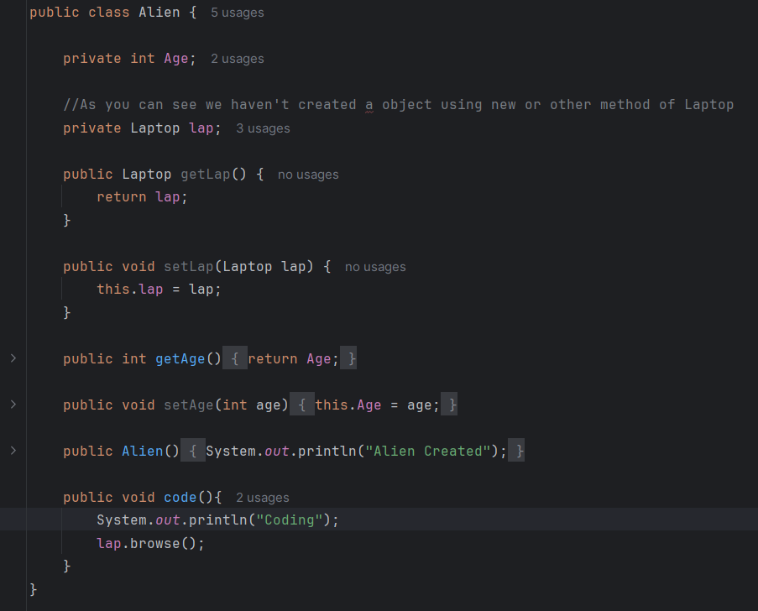
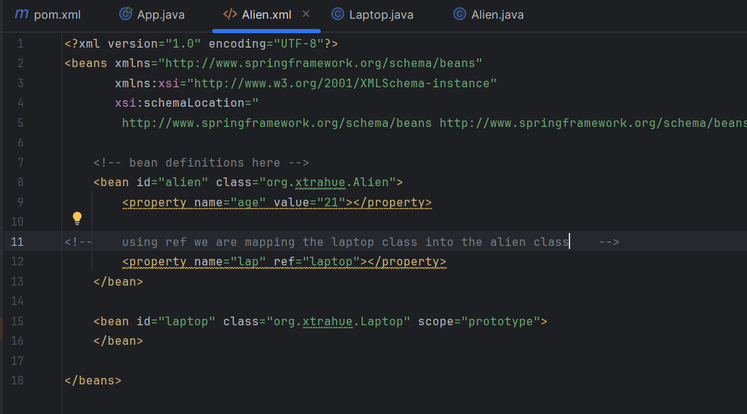

Constructor Injection: For setter injection we were using the property tag, but in constructor injection we will use the Constructor-arg tag.
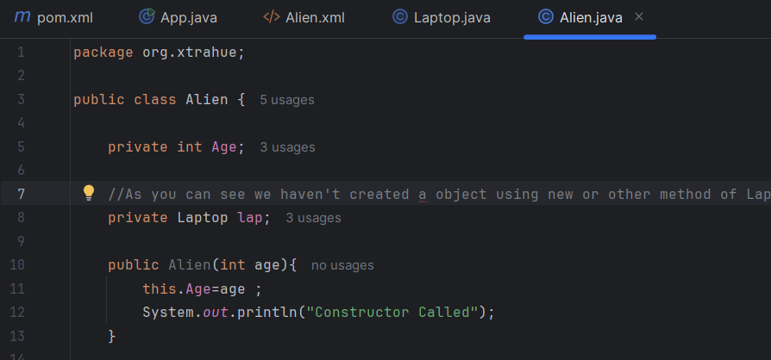
In XML:


- The main problem arises when we have a constructor with multiple parameters. So, in that case we can use index, type, name to create the object. Preferred one is index, because we don’t have to worry about the sequence of the parameters while initializing.

